Store Manager User Guide
QtrShoe Delivery App

1. Overview
The Overview page provides a daily operational summary of store activity. It helps you monitor order progress, delivery performance, system health, and overall workload.
Dashboard Summary

Total Orders
- Total number of orders created today.
- Clicking this card opens the Pipeline section.

Done
• Orders successfully completed.
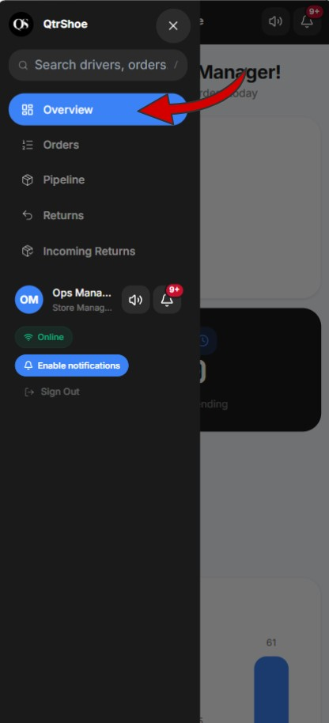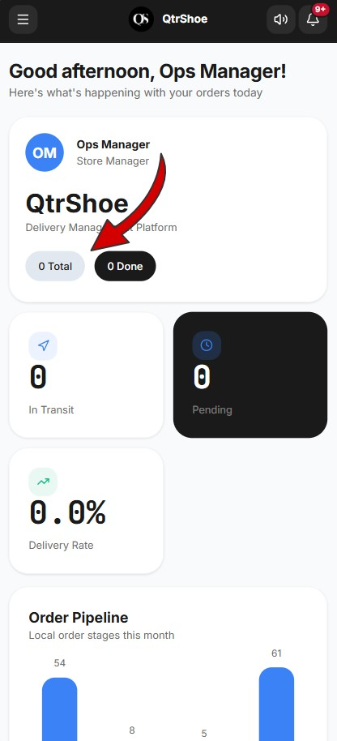

In Transit
- Orders currently being delivered.
- Clicking this card opens Pipeline filtered to In Transit.

Pending
- Orders awaiting action.
- Clicking this card opens Pipeline filtered to Pending.

Delivery Rate
• Percentage of successfully completed deliveries.

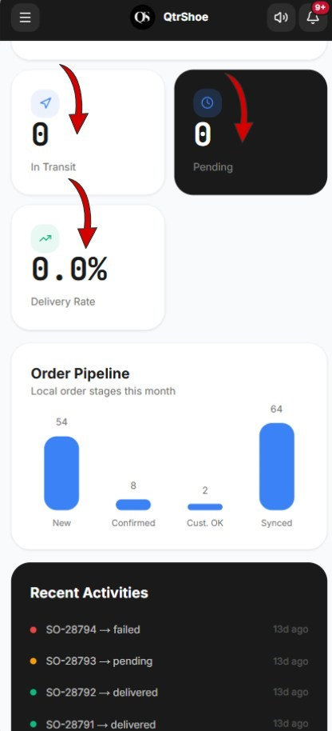

Order Pipeline Chart
Displays monthly order progression through operational stages:
- New
- Confirmed
- Customer Confirmed
- Synced
Use this chart to track processing performance over time.

Recent Orders
Displays the latest 5 orders. Tabs:
- All
- Active
- Done
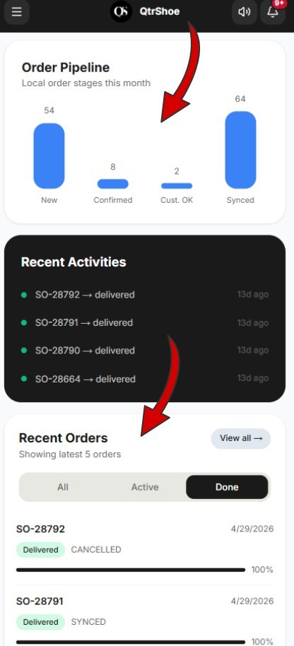

WhatsApp (24h)
Monitors messaging performance over the last 24 hours. Metrics:
- Sent
- Delivered
- Failed

System Overview
Displays platform status indicators:
- Active Zones
- Drivers
- Total Users
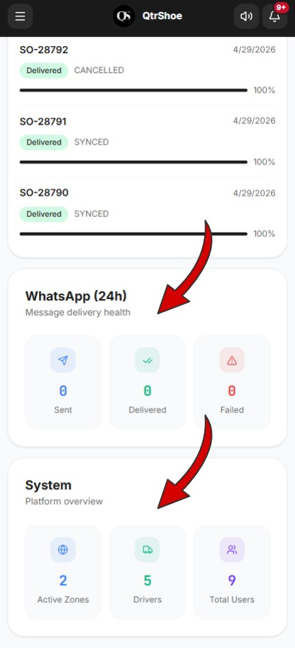
3. Orders Section
A centralized operational monitoring screen used for:
- Searching
- Filtering
- Reviewing all orders
- Monitoring operational exceptions

Main Tabs
- Orders: All delivery orders
- Returns: Return requests
- Exchanges: Exchange orders
- Cancellations: Cancelled orders
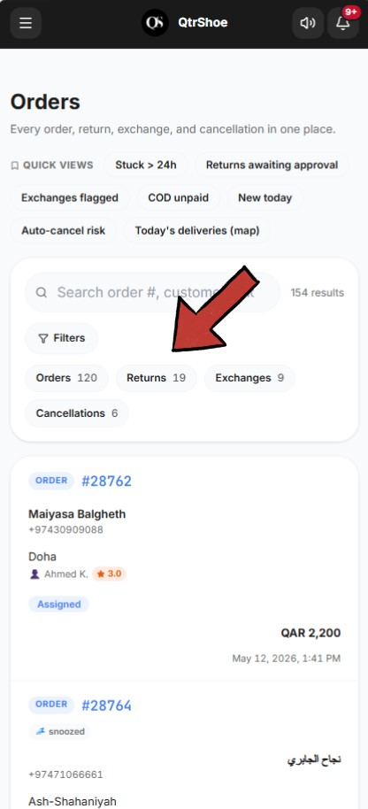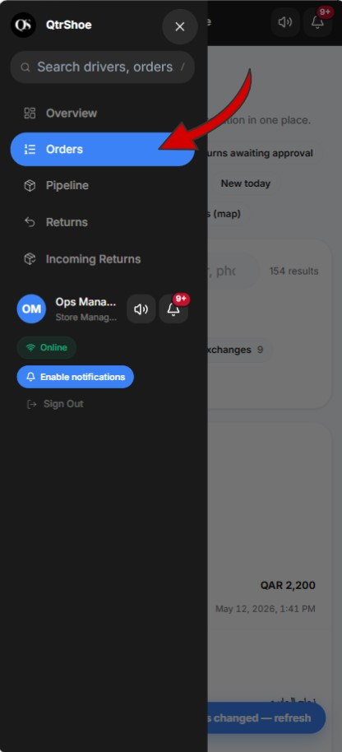
Quick Views (Shortcuts)
- Stuck >24h: Orders with no progress for 24+ hours

• Returns awaiting approval: Pending return approvals
- Exchanges flagged: Exchange requests needing review
- COD unpaid: Cash-on-delivery orders pending settlement (COD = Cash on Delivery)
- New today: Orders created today
- Auto-cancel risk: Orders nearing cancellation due to inactivity
- Today’s deliveries (map): Live geographic delivery view
- Search
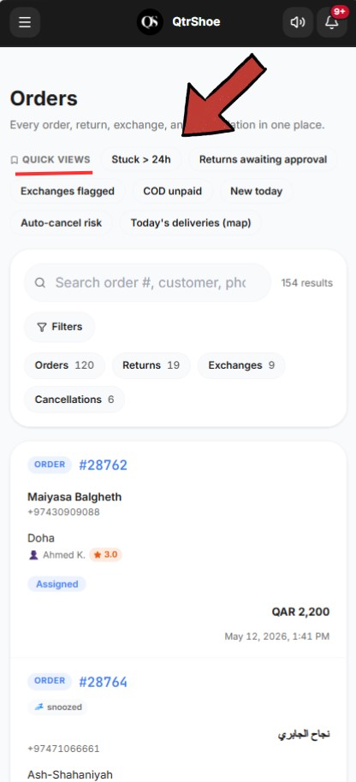

Filters
Delivery Status (examples):
- Pending
- Assigned
- Picked Up
- In Transit
- Delivered
Local Status
- Internal processing stage.

Payment Method
- Cash on Delivery
- Bank Transfer
- Split Payment
Date Range: Custom period filtering.
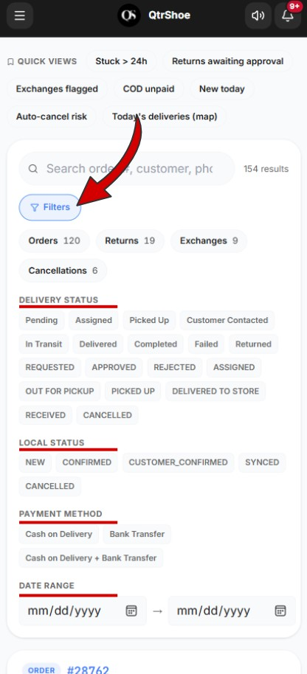
when you click any Quick View, apply any Filter, or make any selection that changes the displayed results, the following four KPIs will update accordingly based on the current results:

• Total Revenue • Cash Collected (COD) • Refunded • Bank Refunds Outstanding

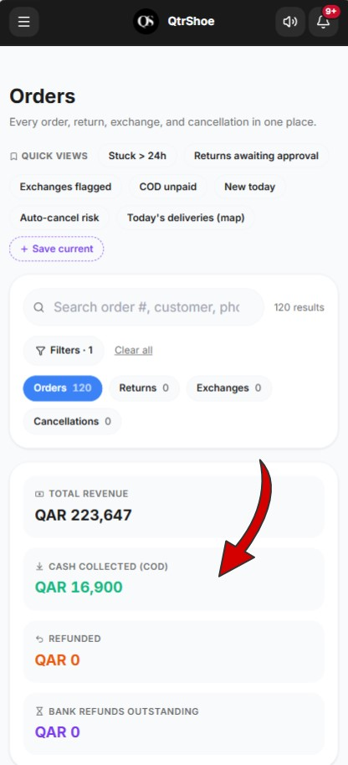

2. Pipeline
The Pipeline manages order progression from creation to completion.

Statuses
- New
- Awaiting
- Ready
- Assigned
- In Transit
- Cancel Review
- Done
- Cancelled

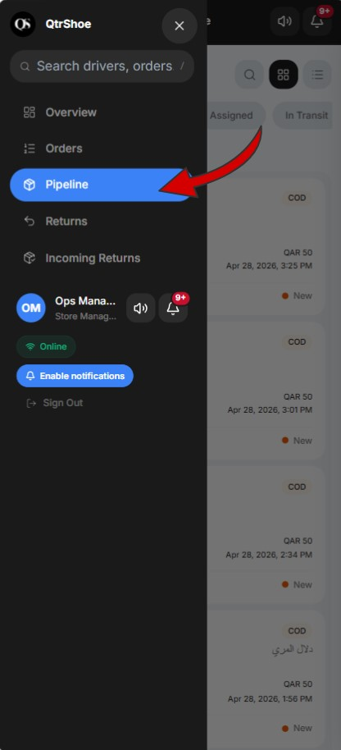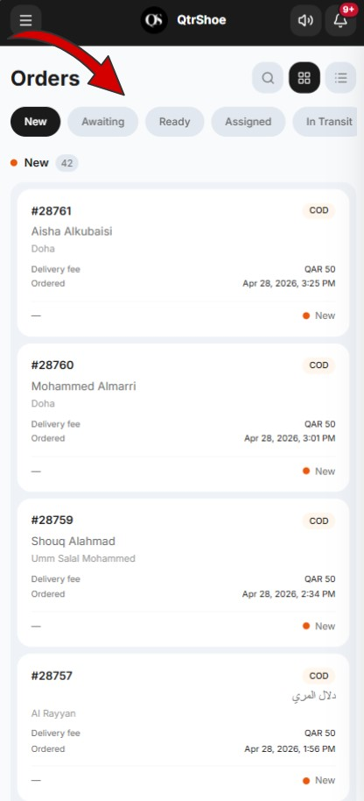
New: Newly received customer orders.
Available actions:
- Confirm Order: Approves the order for processing
- Exchange Order: Marks the order as an exchange request
Important: An exchange can only be initiated if the customer requested it within the last 14 days.
- Combine: Combines this order with another order
Important: You can only combine (pair) this order with another order for the same customer that is currently in any of the first four Pipeline stages. Once combined, both orders will be delivered together with one delivery fee.
- Cancel Order: Cancels the order

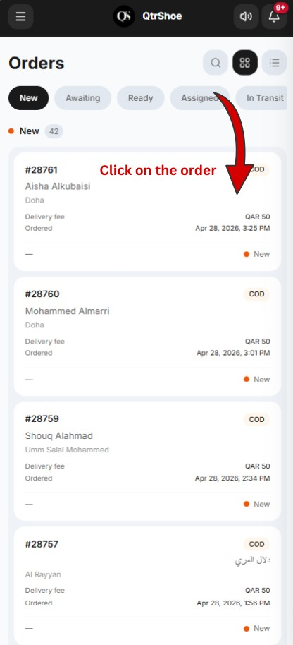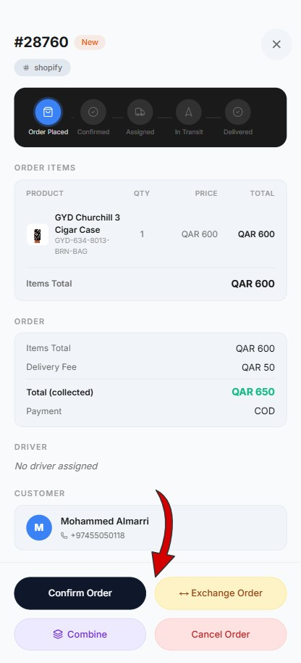

Awaiting
Orders waiting for customer location confirmation.
Available actions:
- Combine
- Cancel Order

Customer Confirmation (Automation)
The customer receives a Location Confirmation Message.
After confirmation, the order progresses to the next stage.
If not confirmed within 48 hours, the order may be automatically cancelled.

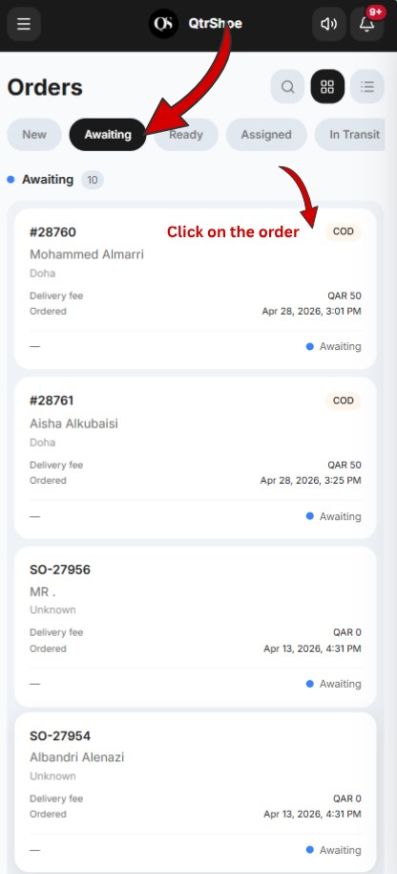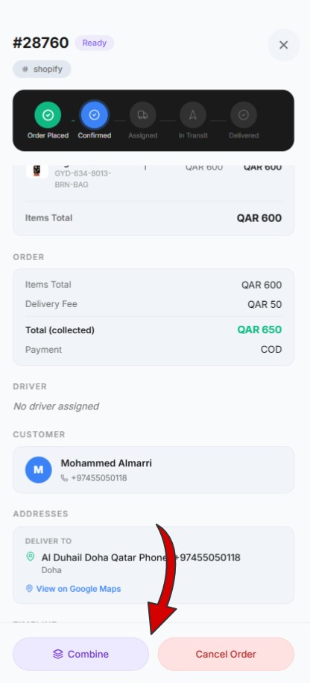

Ready
Orders prepared and ready for driver assignment.
Available actions:
- Combine
- Cancel Order

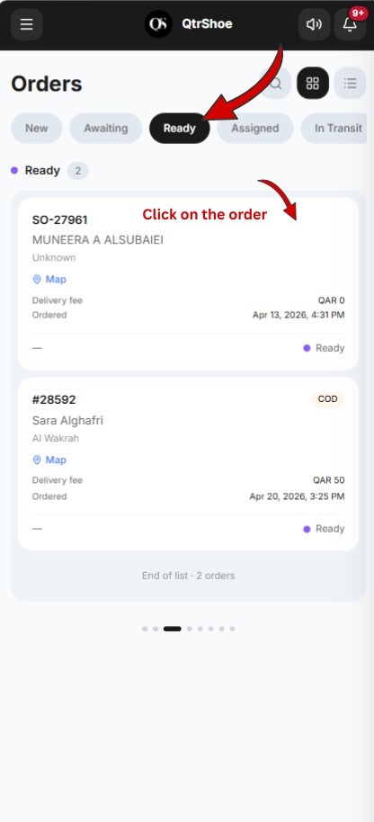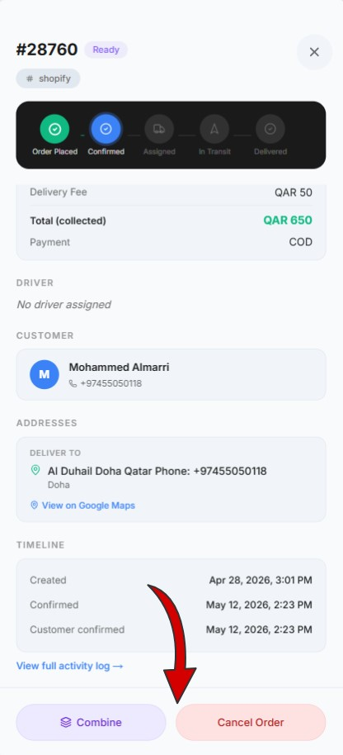

Assigned
Orders assigned to a driver. Displays:
- Driver information
- Order details Available action:
- Cancel Order
- Combine

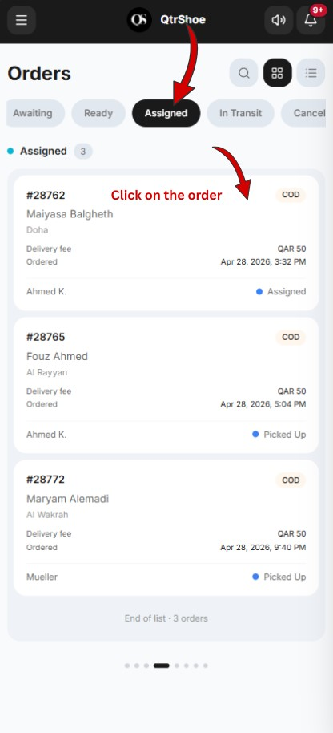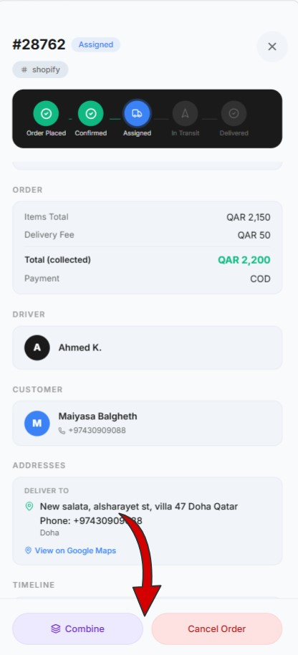

In Transit
Orders currently being delivered.
Displays:
- Driver information
- Order details Available action:
- Cancel Order

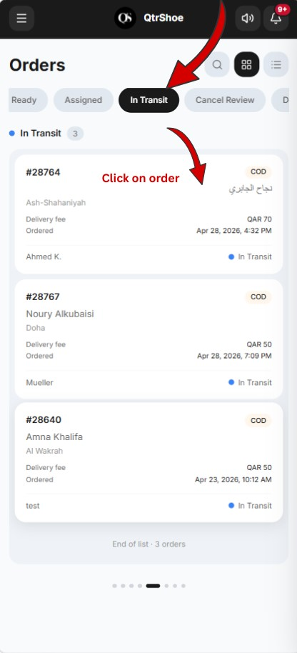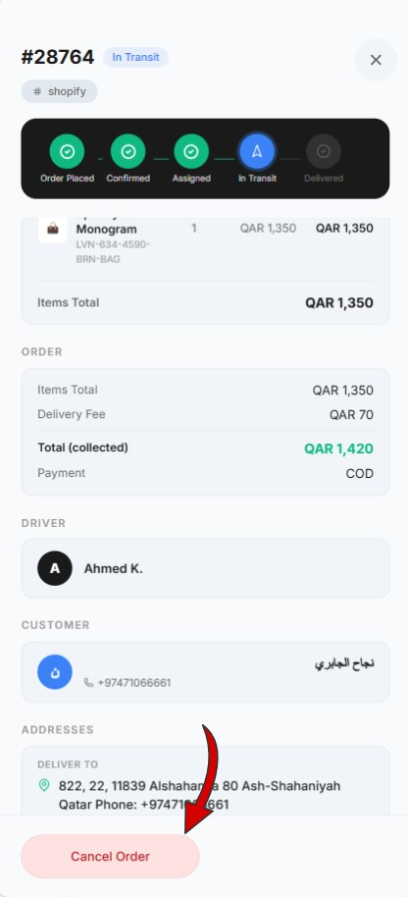

Cancel Review
Displays cancellation requests submitted by drivers.
Shows:
- Driver cancellation reason (e.g., customer phone unreachable, customer not at location, wrong address)
Available actions:
- Confirm Cancellation: Cancels the order
- Reassign: Assigns another driver
- Reschedule: Schedules delivery later note: Contact the customer before deciding whenever possible.

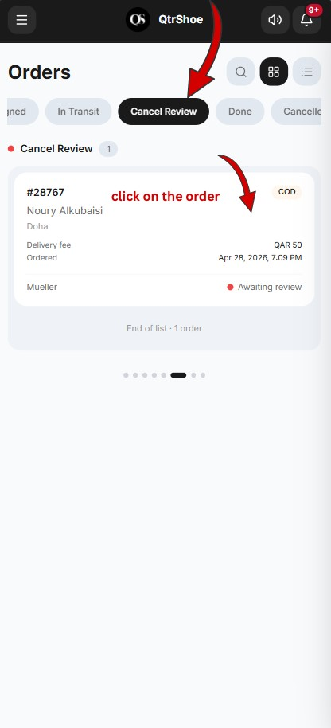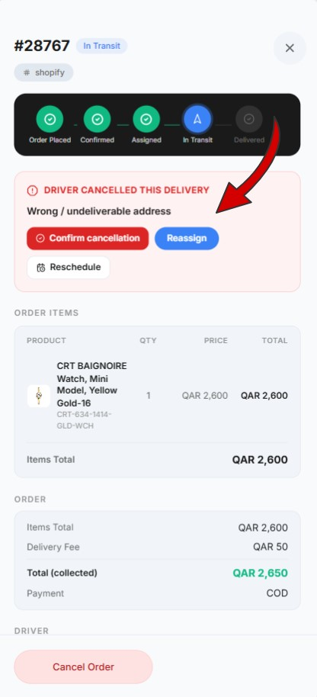

Done
Completed deliveries.
Available action:
• Initiate Return: Used when the customer requests a return
- Select returned products
- Enter return reason
- Submit return request

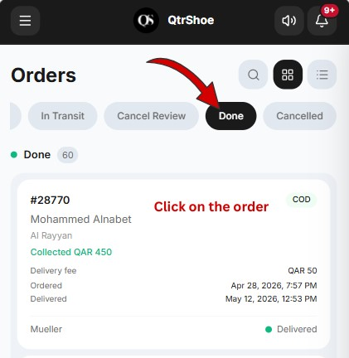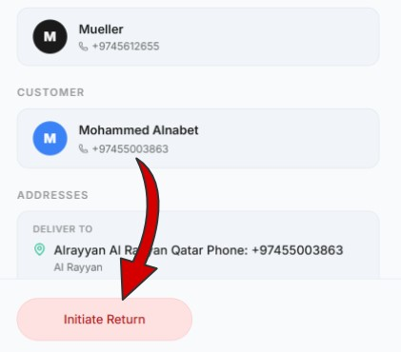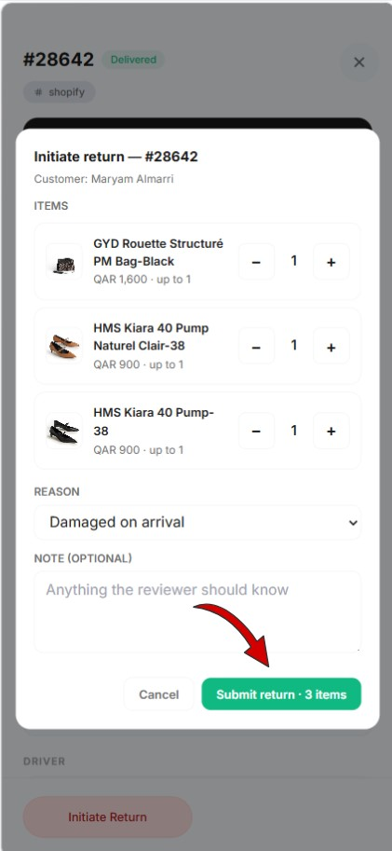

Cancelled
Displays cancelled orders.
View-only.

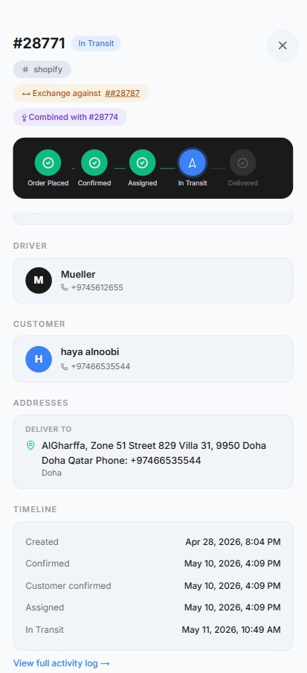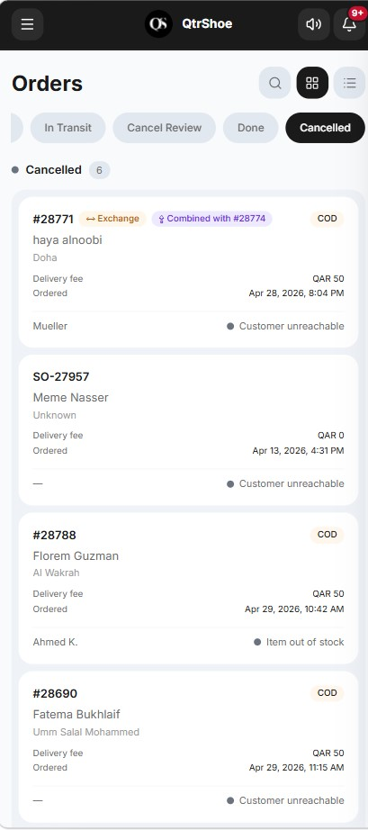

4. Returns Section
Manages customer return requests.
Tabs
- Pending Review
- Active
- Closed

Pending Review
- Customer return requests awaiting decision.
Manager actions:
- Approve: Accept return request
- Reject: Decline return request
Manager can view:
- Return reason
- Order details
- Customer details
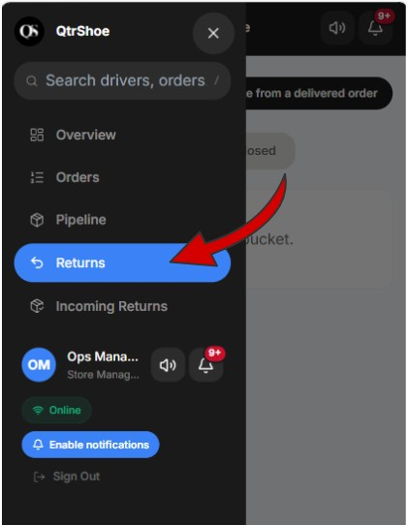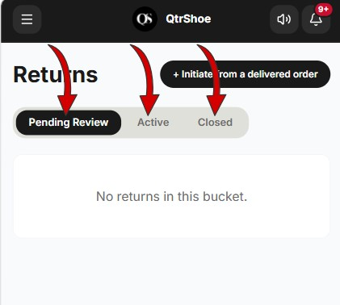

Active
Approved returns currently in progress.
Displays:
- Order
- Customer
- City
- Items
- Driver
- Status
- Requested date Common statuses:
- Approved
- Delivered to Store
- Closed Closed Completed returns.
Status:
- Received in Store

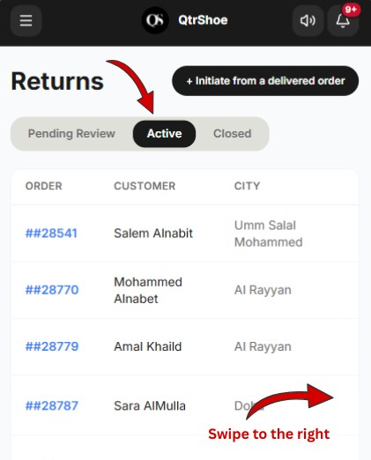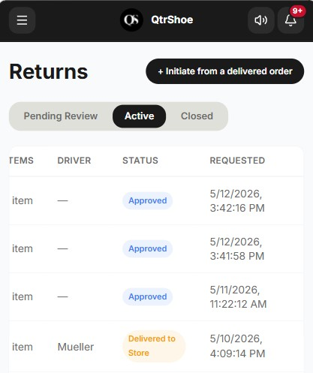

5. Incoming Returns
Tracks physical items expected back at the store.
Example: 3 rejected items · 8 formal returns awaiting receipt

Case 1: Initiated Returns
Items returned after the manager selects Initiate Return.
When the driver brings items back:
• Manager clicks Confirm Receipt

Case 2: Exchange Requests
Items returned after customer submitted exchange request.
Manager can:
• clicks Confirm Receipt (Accept exchange )
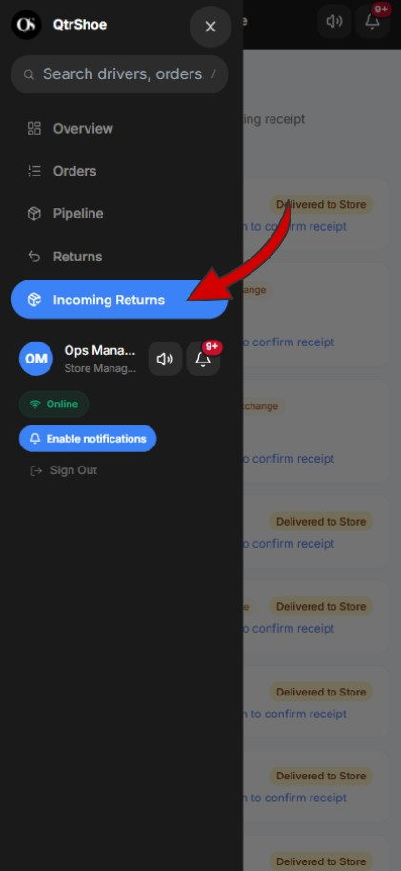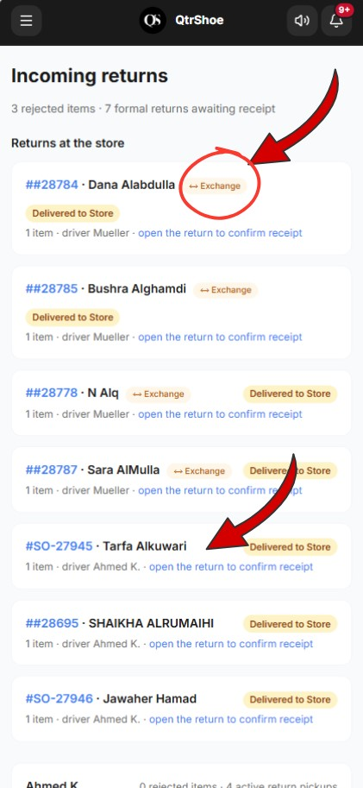
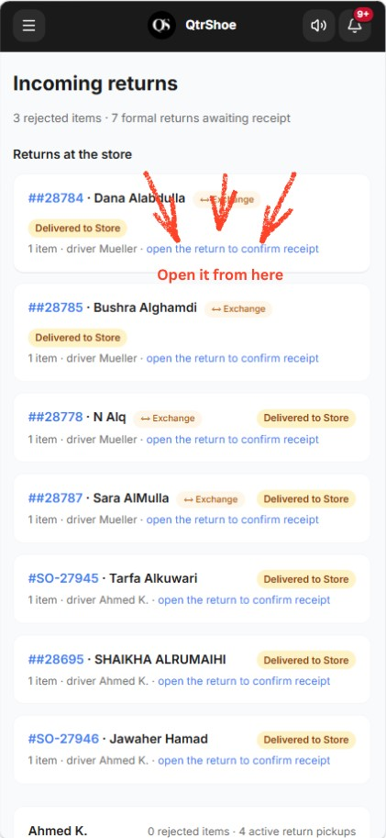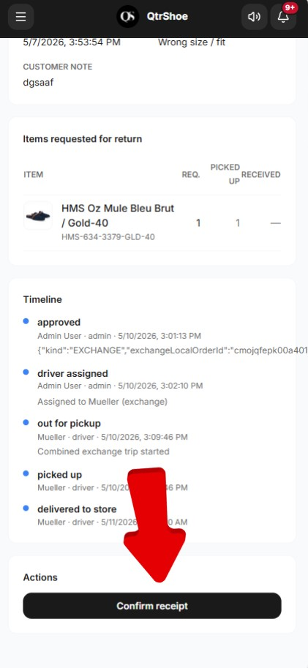

Case 3: Delivery Rejections
Items the customer refused during delivery. These remain visible until physically returned.
• Manager confirms receipt when received.

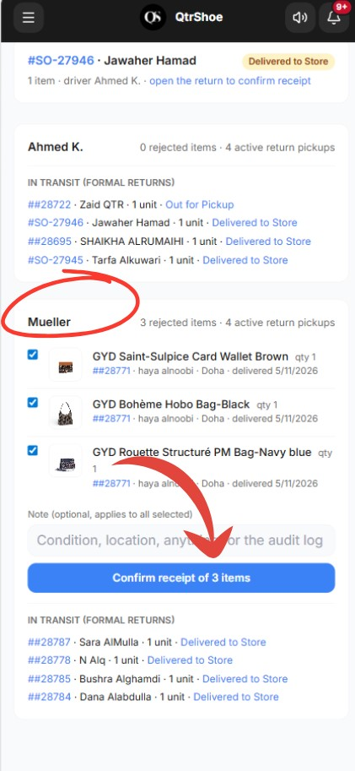

6. Notifications
Store Managers receive real-time operational alerts, such as:
- Delivery Started (driver has started delivery)
- Picked Up (driver confirmed pickup)
- Return Request Submitted (customer submitted return request)
- Exchange Notification (exchange request created)
- Orders Combined Notice (orders merged)
- Return Out for Pickup (return pickup initiated) • Return Complete (return fully completed)
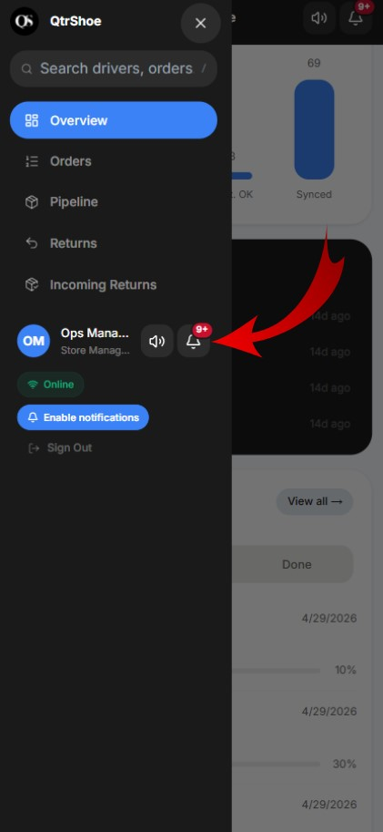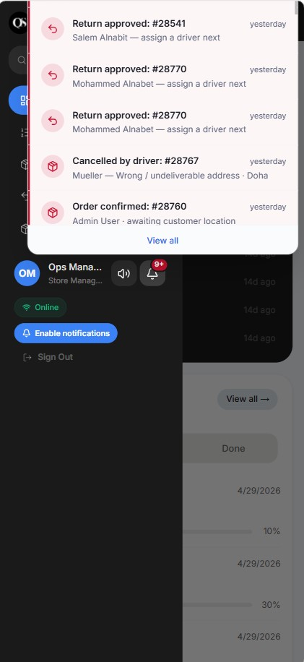

7. Customer Messaging Automation
The system automatically sends customer notifications at key stages.
Awaiting Stage
Location Confirmation Request
Sent when awaiting customer confirmation.
24-Hour Reminder
Warns the customer that the order will be cancelled if not confirmed.

Delivery Started
Customer receives:
• Out for Delivery

Delivery Completed
Customer receives:
- Invoice Delivery (invoice confirmation)
- Return Request Form (allows return submission)

Return Submitted
Customer receives:
• Return Acknowledged

Return Decision
Customer receives one of:
- Return Approved
- Return Rejected
Approved Return
Customer receives:
- Return Out for Pickup
- Return Completed

8. Best Practices
Store Managers should:
- Review new orders promptly
- Monitor stuck orders regularly

• Contact customers before cancellation decisions
• Confirm physical returns immediately upon receipt • Review cancel requests carefully before confirming

